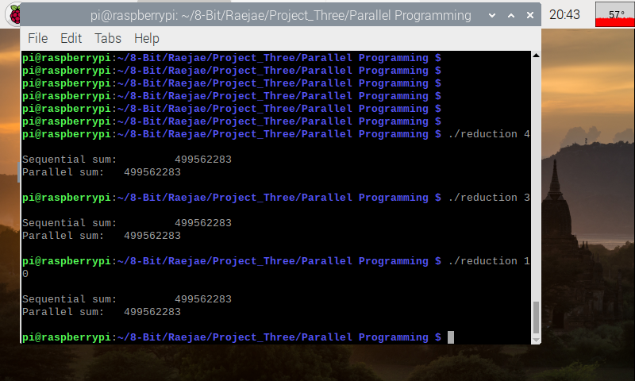

On the initial run of this code without removing the comments there was an issue of the values not matching. This is due to not initializing multi threading which results in a disconnect in values however after uncommenting the values match.

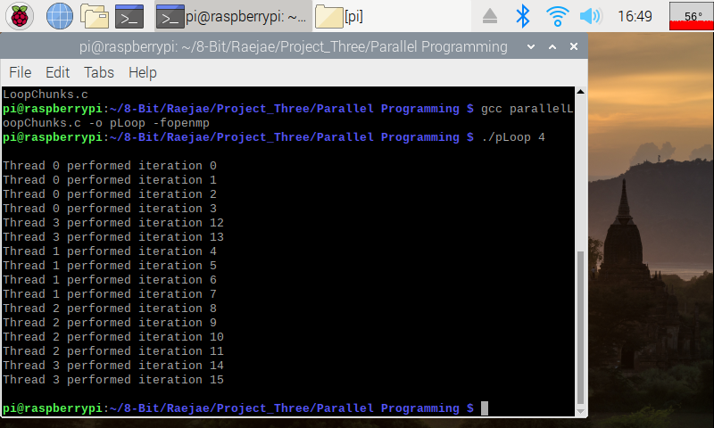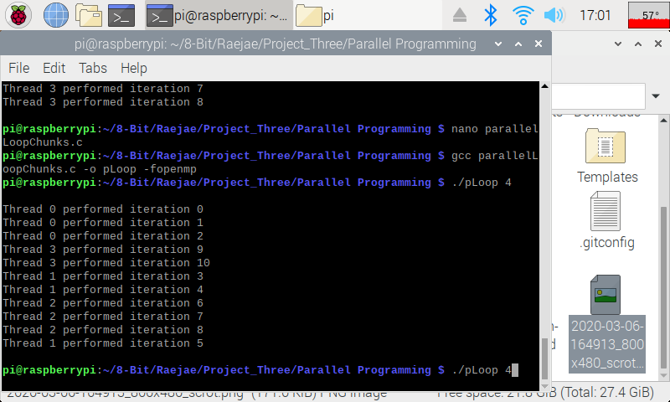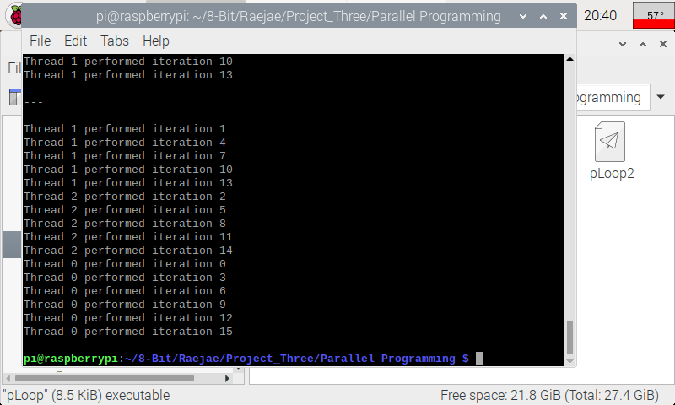

The fun aspect of running the codes for Loops is how the CPU will allocate resource based on its determined priority; moreover how the CPU will subdivide the processes to address the issue with running different iterations. Since they are subdivided each block will approach its handling different. The other cool thing to notice is when using the Loop2 is how the CPU manages optimization with certain threads having different precedence.